

**2020**

**YEAR 11**

**PHYSICAL EDUCATION STUDIES**

**Exam**

**Marking Key**

**Section One: Multiple-choice 20% (20 Marks)**

|  |  |
| --- | --- |
| **Question** | **Answer** |
| **1** | **D** |
| **2** | **C** |
| **3** | **A** |
| **4** | **A** |
| **5** | **D** |
| **6** | **A** |
| **7** | **A** |
| **8** | **B** |
| **9** | **C** |
| **10** | **B** |
| **11** | **B** |
| **12** | **A** |
| **13** | **A** |
| **14** | **B** |
| **15** | **C** |
| **16** | **A** |
| **17** | **A** |
| **18** | **D** |
| **19** | **C or D** |
| **20** | **A** |

# End of Section One

**Section Two: Short answer 50% (67 Marks)**

# Question 21 (12 marks)

1. Name the muscles on the hurdler labeled A to E below: (5 marks)

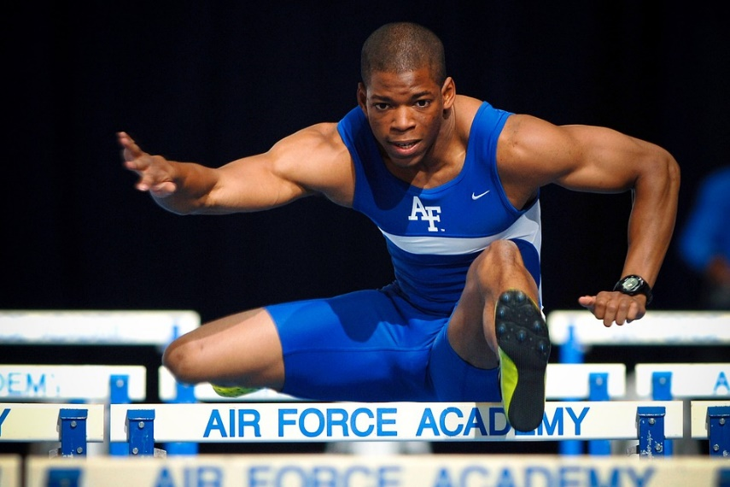

A B B

C D D

E

|  |  |  |
| --- | --- | --- |
| A | Deltoid | 1 mark |
| B | Tricep | 1 mark |
| C | Pectorals | 1 mark |
| D | Bicep | 1 mark |
| E | Quadricep group | 1 mark |

1. A hurdler would benefit from having predominantly which type of muscle fibre? Explain your answer. (3 Marks)

|  |  |
| --- | --- |
| Correctly identify – Fast Twitch fibres Type 2 | 1 mark |
| Description of Fast twitch Fibres   * + Rapid contraction speed – used for speed, strength and power-based activities   + Generate greater force and more powerful contraction | 1 mark (any one point) |
| Correct link to hurdle event and physiological demands | 1 mark |
|  | Total 3 marks |

1. Identify two joint movements at the hip and knee for both the trail leg and lead leg of the above pictured hurdler (4 marks)

|  |  |
| --- | --- |
| Abduction of the hip joint on trail leg | 1 mark |
| Flexion of the lower leg at the knee on trail leg | 1 mark |
| Flexion at the hip on lead leg | 1 mark |
| Extension of the lower leg at the knee joint on lead leg | 1 mark |
|  | Total 4 marks |

**Question 22 (9 marks)**

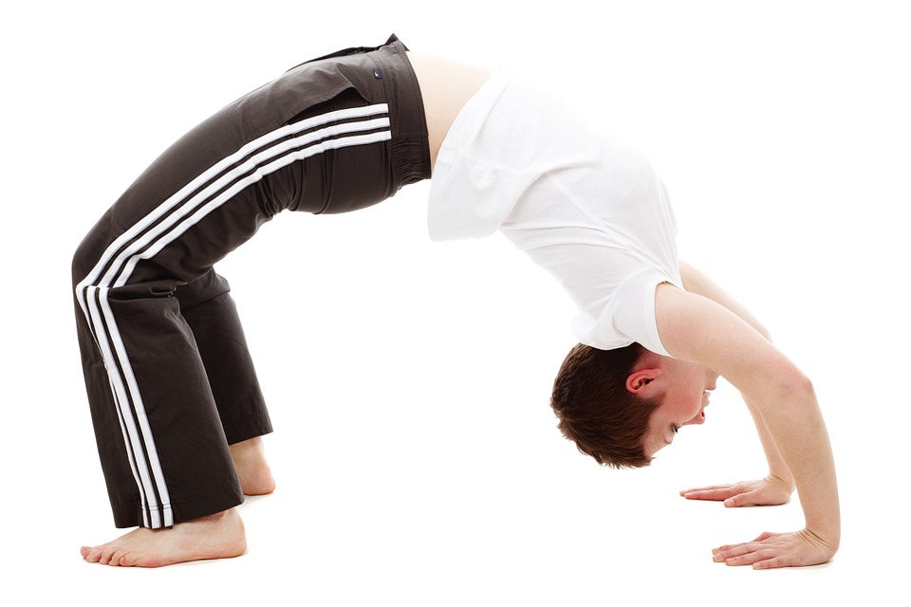

Line of Gravity – 1 mark

Centre of Gravity – 1 mark

The ‘bend back’ is a gymnastic movement which requires a significant amount of flexibility and strength to perform well.

1. Using the picture above identify and draw the location of the gymnasts ‘Centre of Gravity’ as well as the ‘Line of Gravity’ (2 Marks)
2. Human beings do not remain fixed in the anatomical position and therefore the precise location of the Centre of Gravity changes constantly with every new position of the body and limbs, including ‘Bend backs’. Discuss this statement and make reference to the above picture. (4 Marks)

|  |  |
| --- | --- |
| The centre of gravity is defined as the point around which a body’s weight is equally balanced in all directions. | 1 mark |
| For each arm/leg movement the centre of gravity shifts slightly towards the direction of movement | 1 mark |
| The flexibility and complexity of the human body allows the body to assume various positions where the centre of gravity may lie outside the body | 1 mark |
| Link to bend back – Arc of body shifts Centre of Gravity outside the body | 1 mark |
|  | Total 4 marks |

1. Using the picture above of the movement of the bend back, explain how muscles work in pairs. In your answer refer specifically to one of the limbs. (3 Marks)

|  |  |
| --- | --- |
| Muscles work in pairs, each contracting or relaxing in turn to create movement. | 1 mark |
| The muscle doing the work (contracting) and creating the movement is called the agonist or prime mover. The muscle which is relaxing and letting the movement take place is called the antagonist. | 1 mark |
| Appropriate link to ‘bend back’ movement | 1 mark |
|  | Total 3 marks |

**Question 23 (8 marks)**

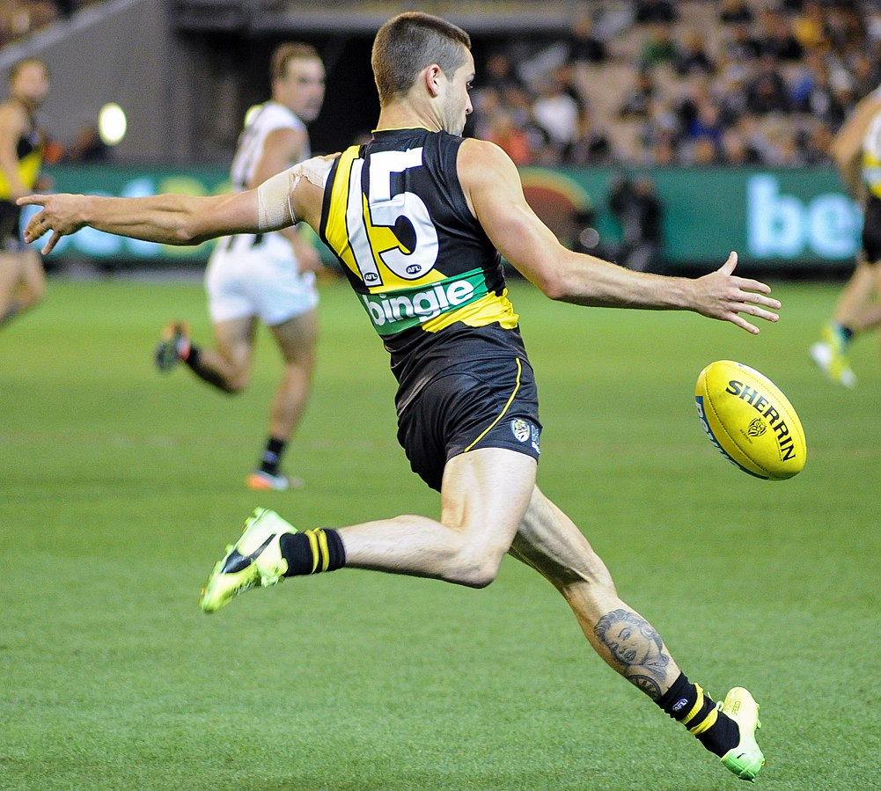

In building foot speed to kick the ball, the hip, knee and ankle are used.

1. Classify what type of movement this is from the coordination continuum. (1 mark)

|  |  |
| --- | --- |
| Sequential movement | 1 mark |

1. On the graph below, draw and label the optimal timing of the action of the hip, knee and ankle joints for maximum foot velocity, when kicking the ball. (3 marks)



Ankle joint

Knee

Hip

1. Describe the two biomechanical factors that would maximize the velocity of impact with the ball.

One (2 marks)

|  |  |
| --- | --- |
| Principle - Momentum | 1 mark |
| More body mass the more power generated  Transfer body weight forward to generate velocity (objects state of motion, the combined measure of speed of an object and direction of movement) | 1 mark |
|  | Total 2 marks |

Two (2 marks)

|  |  |
| --- | --- |
| Principle – Dynamic Balance | 1 mark |
| Maintain balance through a variety or sequence of moves, determines the velocity and direction of object  Make momentum as focused as possible | 1 mark |
|  | Total 2 marks |

# Other possible principle – Sequential Movement, Summation of Forces, Newtons 2nd Law

**Question 24 (8 marks)**



When 2019/2020 Iron woman champion, Lana Rogers, commences a race changes occur to her respiratory and circulatory systems.

1. Provide one example of an immediate physiological response in her respiratory system and one example in her circulatory system. (2 marks)

|  |  |
| --- | --- |
| Any one of: Circulatory   * Increased heart rate, stroke volume, AV02 diff, cardiac output, blood pressure | 1 mark |
| Any one of: Respiratory   * Increased ventilation, tidal volume, respiratory rate or diffusion | 1 mark |
|  | Total 2 marks |

1. Explain why the respiratory and circulatory system respond in this way. (2 marks)

|  |  |
| --- | --- |
| The body responds to the commencement of exercise by increasing all the processes involved in transporting oxygen to the working muscles. Allows working muscles to move and perform required task. | 2 marks |

In the lead up to the 2019/2020 competition season, Lana focused on improving her cardiorespiratory endurance. In consultation with her coach and trainer, she began an exercise program designed to emphasise continuous training, rather than interval training.

1. Identify the key difference between continuous and interval training. (1 mark)

|  |  |
| --- | --- |
| Interval Training:  Series of repeated bouts of exercise with pre-determined rest periods or active recovery | 1 mark |
| Continuous Training  Involves sustained activity for period over 20min |

1. Discuss how the principle of specificity could be applied in the continuous program for this athlete. (1 mark)

|  |  |
| --- | --- |
| To achieve maximal benefits, Lana’s program should reflect the specific demands of the sport. Training using continuous training method in all disciplines | 1 mark |

The graph below shows the effect that exercise has on the percentage distribution of blood to different systems of the body for Lana Rogers.

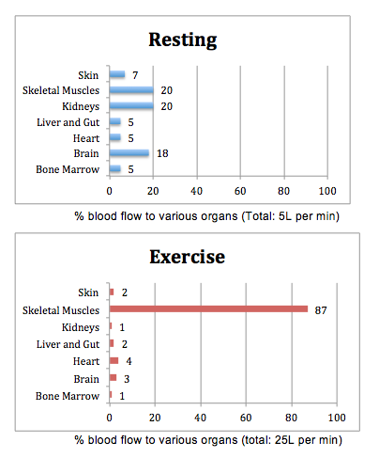

1. Outline how and why blood is distributed away from major organs to working muscles as exercise intensities increase. (2 marks)

|  |  |
| --- | --- |
| During exercise, arteries vasodilate and vasoconstrict to allow more or less blood to reach certain areas of the body. | 1 mark |
| This increases the amount of blood available to the working muscles, increase oxygen supply to working muscles. | 1 mark |

**Question 25 (4 marks)**

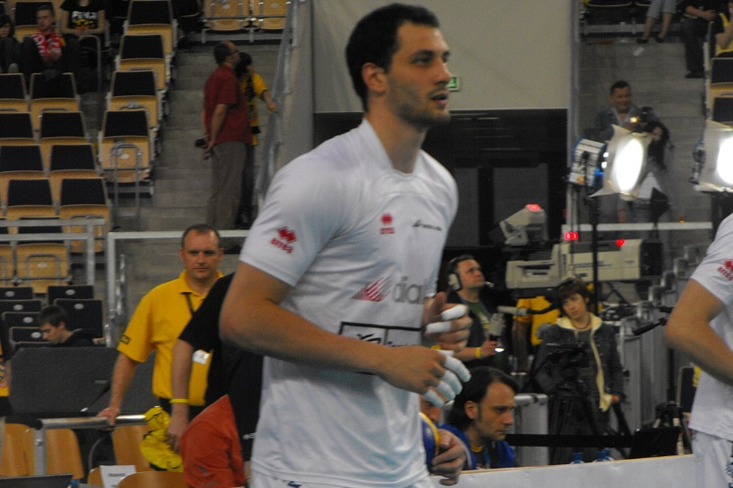

Professional Volleyball player Matey Kaziyski of Bulgaria, on average, will spike the ball at 130km/h. Explain Newtons 1st and 2nd laws of motion as applied on the above picture of a spike.

|  |  |
| --- | --- |
| Newtons 1st law - A body continues in its state of rest or state of motion unless acted upon by a force | 1 mark |
| Volleyball will continue in its motion down to the ground until acted on by Matey’s spike | 1 mark |
| Newtons 2nd law - The rate of change of acceleration to a body is proportional to the force applied to it | 1 mark |
| Matey applies a large force onto the volleyball which results in a greater acceleration | 1 mark |
|  | Total 4 marks |

**Question 26 (5 marks)**

Two athletes have been asked by their coach to share what they consume prior to a club Football (soccer) game which generally last for 90 mins.

|  |  |  |
| --- | --- | --- |
| *Athlete 1* |  | *Athlete 2* |
| *2 hours before the game*   * *Half a pepperoni pizza* * *Can of coke zero* * *Apple*   *30min before the game*   * *Mars bar* |  | *3 hours before*   * *Fried rice with vegetables and ham* * *500ml water*   *1 hour before*   * *banana smoothie with no fat milk* |

Using your knowledge of fuel sources, compare the two athletes pre-game meal preparations. Assuming both athletes are at the same fitness level which one would fatigue quicker due to their pre-game meal, explain why?

|  |  |
| --- | --- |
| Identify 3 fuel sources – Carbohydrates, Fats and Proteins | 3 mark |
| Identify Athlete 1 would fatigue quicker | 1 mark |
| Explanation identifying that Athlete 1 has higher GI foods, limited Carbohydrates and especially prior to game, therefore glycogen stores will be depleted faster than athlete 2 | 1 mark |

**Question 27 (6 marks)**

(a) Explain what is meant when an athlete says they are ‘in the zone’. (2 marks)

|  |  |
| --- | --- |
| Ideal performance state - performer attends only to relevant stimuli in the environment and can shift their attention quickly to meet the needs of the situation | 1 mark |
| Not under aroused or under aroused | 1 mark |

(b) Using the Inverted U Hypothesis, draw a diagram depicting the Optimal Arousal Zone for a sport of your choice. Sport: ___________________________________

Diagram (1 mark)

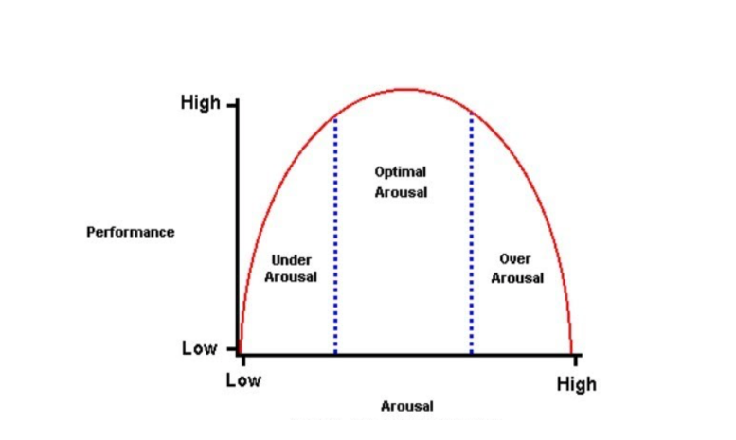

(c) Describe the Inverted U Hypothesis in relation to arousal. (3 marks)

|  |  |
| --- | --- |
| Under aroused - performance will be less than optimal and attention being given to irrelevant cues and a lack of concentration. | 1 mark |
| Optimal arousal level with the corresponding optimal performance level and | 1 mark |
| Over-arousal with the corresponding drop in performance due to increased muscular tension and the missing of important cues in the environment. | 1 mark |
|  | Total 3 marks |

**Question 28 (9 marks)**

The following workout plan was given to Amber, a surfer who was seeking to improve her fitness.

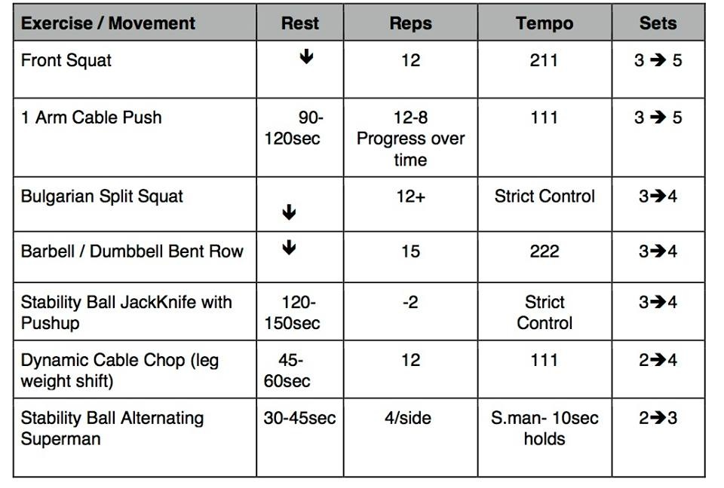

1. Would you recommend this workout for a surfer? ­­­­­­­­­­­­­­­­­­­­ (1 Mark)

|  |  |
| --- | --- |
| Yes, as it focuses on key muscle groups/dynamic movements specific to surfing | 1 mark |

1. List 2 training methods included in this program. (2 Marks)

|  |  |
| --- | --- |
| Resistance | 1 mark |
| Circuit | 1 mark |

1. Explain 3 specific adaptations you would expect to see after using this program for 8 weeks. (6 Marks)

|  |  |
| --- | --- |
| Muscular Endurance | 1 mark |
| Specific example from program | 1 mark |
| Muscular Strength | 1 mark |
| Specific example from program | 1 mark |
| Dynamic Flexibility/Movement | 1 mark |
| Specific example from program | 1 mark |
|  | Total 6 marks |

**Question 29 (3 marks)**

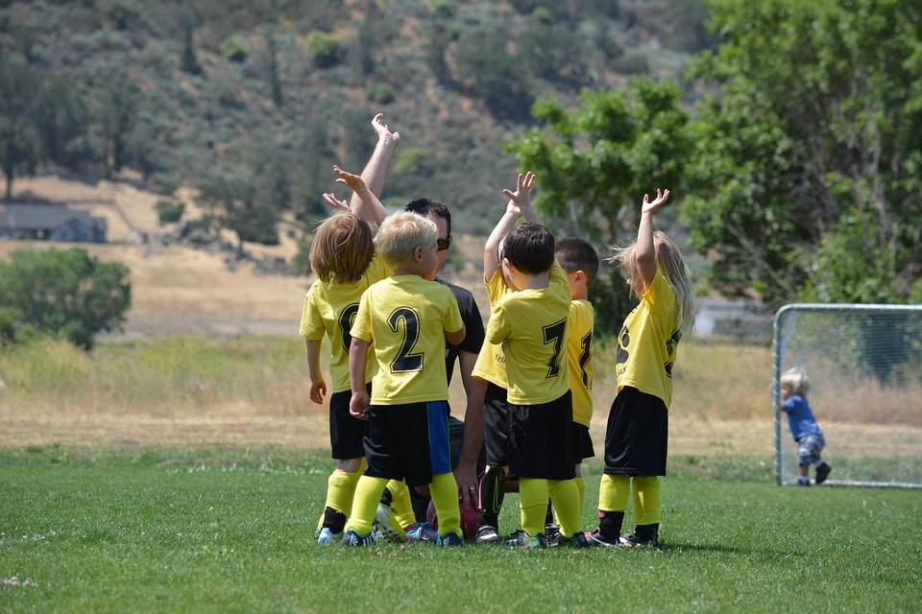

1. What stage of learning would you expect the children in the picture above to be in?

(1 mark)

|  |  |
| --- | --- |
| Cognitive | 1 mark |

1. Discuss the type of feedback these children would most benefit from. (2 Marks)

|  |  |
| --- | --- |
| Positive and encouraging  Not specific to small movements  Reminders of cues and sayings | 2 marks max |

**Question 30 (3 marks)**

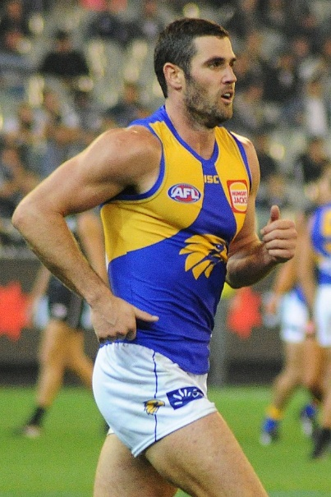

Jack Darling of the West Coast Eagles tells you that he has been using imagery to improve goal kicking. But he says it has made him worse at set shots. Having asked what does he imagine, he says: “when I am running in to kick at goal, I mentally rehearse and see how I don’t want things to go, then I imagine a good kick while I am kicking it”. What advice do you have for Jack on his use of imagery? (3 marks)

|  |  |
| --- | --- |
| Imagery is the recreation of the performance, in the mind, of a skill or group of skills, a previous positive experience to prepare an individual mentally for performance. | 1 mark |
| Identify that he is focusing on a negative performance and thinking while completing the skill is a distraction | 1 mark |
| Tell Jack to focus on a positive experience and try not think/imagery while executing the skill | 1 mark |
|  | Total 3 marks |

# End of Section Two

**Question 31 (15 marks)**

Kenyan Athletes are well known to be leaders in middle to long distance running events. The ‘High Altitude Training Centre’ in Kenya is considered one of the best in the world for those looking to improve performance of their cardio-respiratory system. Many athletes are unable to travel to Kenya to train but are still able to promote positive adaptations using specific training methods.

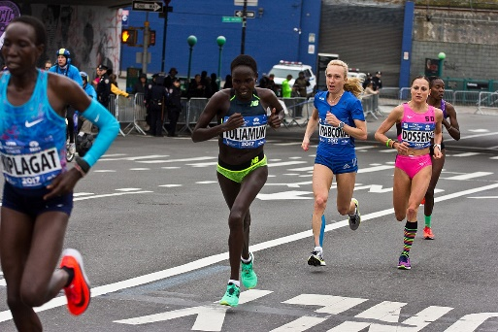

1. Identify three training methods a 1500m runner could use to develop positive adaptations and describe specific adaptations you would expect to see for each training method. (9 Marks)

|  |  |
| --- | --- |
| **Description** | **Marks** |
| **Training methods:**   * Fartlek * Interval * Continuous | 1 mark each |
| **Adaptations - Can be but not limited to:**  **Fartlek –** increased acid buffering ability, improved fast twitch response  **Interval –** Increased VO2 max, increased stroke volume, increased mitochondria  **Continuous-** IncreaseVO2 max, increase ventricular size, increase stroke volume increased capillarisation, increase mitochondria. | 2 marks for specific adaptations for each method |
|  | Total 9 marks |

1. Identify three fitness tests to measure the dominant components of fitness which are required in 1500m runners. Discuss why they suit 1500m runners. (6 Marks)

|  |  |
| --- | --- |
| **Description** | **Marks** |
| **Beep test –** A test of cardio-vascular endurance which is a dominant energy system in the later parts of a 1500m race.  **VO2 Max test –** A test of the cardio-vascular system, specifically testing the ability of the body to utilize oxygen.  **Yo-Yo test** – A test that measures cardio-vascular endurance.  Has rest intervals so also tests lactate qualities. This demonstrates the athlete’s ability to buffer Hydrogen ions, allowing them to utilise the lactic acid system for longer in the race.  *Other correct answers* | 1 mark correct test  1 mark each reason |
|  | Max 6 marks |

**Question 32 (15 marks)**

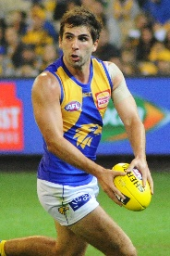

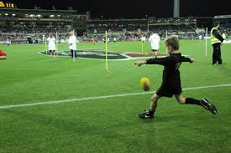

**Andrew Gaff Jack**

Andrew Gaff is a player on the West Coast Eagles team in the AFL. He has been selected in multiple All Australian teams and won club Best and Fairest awards.

Jack is a 6 year old AusKick player who is in his first year of playing for a team.

1. Suggest the stage of learning each of these AFL players would be in and outline two characteristics of each stage. (6 marks)

|  |  |
| --- | --- |
| **Description** | **Marks** |
| Andrew Gaff - Autonomous stage  Jack – Cognitive stage | 1 mark  1 mark |
| **Characteristics:**  **Autonomous stage** – high success rate, low amount of errors, can filter required cues, quick processing of information, can give self-feedback.  **Cognitive stage** – Low success rate, the thinking stage, needs constant external feedback, slow processing of cues. | 2 marks  2 marks |

1. Using the Information Processing Model, discuss how the experiences on the field would differ between Andrew and Jack. (9 Marks)

|  |  |
| --- | --- |
| **Description** | **Marks** |
| **Must outline experiences from each stage of the Information Processing model.**  Describes the information processing model.   * A model that describe the stages of processing information from receiving a stimulus to acquiring feedback after an action is performed.   **Input**  *Andrew Gaff* – Can assess more options and understand finer detail in cues.  *Jack* – Focus only on immediate situation, can cause stress due to large amount of input.  **Processing**  *Andrew Gaff* – Can filter cues quickly and determine best response, uses previous experience to choose best option.  *Jack* – Takes time to choose response, will often not be the best option  **Output**  *Andrew Gaff* – Performs skill with accuracy and success most of the time.  *Jack* – Performs skill with low success rate.  **Feedback**  *Andrew Gaff* ***–*** Cangiveown feedback and determine success of the skill.  *Jack* – Needs feedback from others such as coach or parents. | 1 mark  2 marks  2 marks  2 marks  2 marks |
|  | Total 9 marks |

**Question 33 (15 marks)**

The ‘Tour De France’ is one of the world’s most famous cycling events. It takes place annually in France and consists of 21 day-long segments, (stages) covering approximately 3500km.

1. Riders of the ‘Tour De France use bicycles made of carbon fibre as they are extremely lightweight compared to an aluminium frame. With reference to **one** of Newtons Laws, explain why cyclists will benefit from using a bicycle that has a very light frame. (3 marks)

|  |  |
| --- | --- |
| **Description** | **Marks** |
| **Accurate description of Newtons 2nd Law**  2nd Law – An objects acceleration is dependent on the mass of the object and the force applied to it. | 1 mark |
| **Benefits explained:**  If the object is light, the force required to move it is less **OR**  A heavy object will require more force to move it.  **OR** A lightweight bike frame requires less force to move than heavy frame.  Being such a long race, the rider will produce less force as the race goes on, with a light frame the rider can produce greater force for longer with less fatigue. | 1 mark  1 mark |
|  | Total 3 marks |

1. The ‘Tour De France’ is an extremely challenging event, both physically and mentally. Riders continually push their bodies to the limit over 21 days. Mental skills play a very important role in the riders success.

Discuss **three** strategies that a rider could use to manage mental issues such as motivation, concentration and arousal.

(6 marks)

|  |  |
| --- | --- |
| **Description** | **Marks** |
| **Self -Talk**   * Riders can use positive self-talk to motivate themselves. Tell themselves they can do it. Remind themselves of past success.   **Imagery**   * Riders can use positive imagery to picture themselves finishing the stage well. Improving concentration and ensuring focus on required stage of each race.   **Relaxation techniques**   * Riders can use relaxation techniques such as music, breathing techniques to ensure arousal levels remain at optimum levels. | 1 mark correct strategy  1 mark correct description  (2 marks each strategy max) |

1. Throughout the race the riders will use 3 different energy systems. Discuss the fuels

needed to be consumed by the rider to ensure each energy system performs at peak levels. (6 marks)

|  |  |
| --- | --- |
| **Description** | **Marks** |
| **ATP-PC System**   * Relies on stored glucose and PC as fuel. * Riders should ensure they consume carbohydrates. Examples will vary   **Lactic Acid System**   * Relies on carbohydrates and lactate as fuel. * Riders should ensure they consume carbohydrates. Examples will vary   **Aerobic System**   * Relies on fats as fuel. * Riders should ensure they consume good fats in their diet. Also oxidises stored fats. Examples will vary | 2 marks max per system |
|  | Total 6 marks |

**Question 34 (15 marks)**

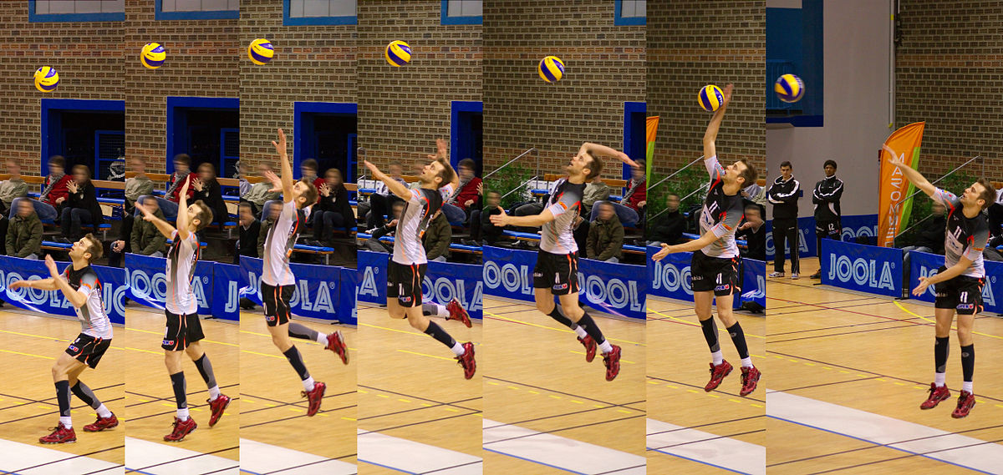The image elow shows the movements of a volleyball player as they perform a serve. The aim of the serve is to hit the ball across court into the opponents service box. The faster the ball travels, the less time the opponent has to react.

1. With reference to ‘base of support’ and ‘centre of gravity’, explain how the player moves to manipulate his balance and stability to create a successful serve.

(6 marks)

|  |  |
| --- | --- |
| **Description** | **Marks** |
| **Base of support**   * The wider a base of support, the more stable an object is. **OR** a narrow base of support leads to a less stable object. * The player purposefully moves his feet close together to cause his balance to be in front of his body. * This causes the player to move into the court as he serves.   **Centre of gravity**   * As the player leans forward his centre of gravity moves in front of his body. * The athlete deliberately causes his body to move into the court by adjusting his centre of gravity. * He moves forwards into the court as he serves, increasing forward momentum.   **Or** other correct statements | 3 marks max  3 marks max |

1. Outline three components of fitness a volleyball player should be training and suggest a method of training for each component. (6 marks)

|  |  |
| --- | --- |
| **Description** | **Marks** |
| **Answers can include but are not limited to:**  **Muscular Endurance** – ability of a muscle to perform efforts over an extended period of time.  Methods of training - Interval training, fartlek training, circuit training.  **Agility –** Ability of a person tochange direction or move quickly to avoid or attack. Methods of training – plyometric training, speed training  **Hand-Eye Co-ordination –** Ability of a person to judge the movement of an object to catch or strike effectively.  Methods of training – Sport specific training, circuit training | 1 mark each component  1 mark each method |
|  | Max 6 marks |

1. Outline the two different types of balance and suggest the type of balance a volleyball player would use more frequently. (3 marks)

|  |  |
| --- | --- |
| **Description** | **Marks** |
| **Static Balance** – ability to maintain a stable base of support in a stationary position.  **Dynamic Balance –** ability to maintain balance and control while moving.  The volleyball player would more frequently use dynamic balance. | 1 mark  1 mark  1 mark |
|  | Total 3 marks |

**End of Section Three**